**Software Requirements**

**Specification**

**for**

**Supermarket Automation Software**

**(SAS)**

# Introduction

## 1.1 Purpose

The main objective of the SRS document of the SAS is to provide a base for the foundation of the project. It gives a comprehensive view of how the system is supposed to work and what is to be expected by the end users.

The Supermarket Automation Software mainly focuses on:

1. maintaining and keeping records of stocks
2. generating bills after getting the scanned codes of the items
3. generating sales record to keep track of gain or loss of supermarket.

It will reduce the paperwork also the large amount of data is now stored in database which will reduce clumsiness and last but not the least. It will reduce the time spent in calculation of Sales, stock and transaction activities so that users can spend more time on monitoring the Super-Market.

## 1.2 Document Conventions

The document convention is easy to understand and simplified. All major section like the Headings and subheadings are in bold and having large font size. Hyperlinks (if any) are indicated by blue colour.

## 1.3 Intended Audience and Reading Suggestions

The intended audience for the system is shop owner, manager, vendor and buyer.

* Shop owner- The head of the company who will have the access to the sales function, stock report and payment transaction.
* Manager- The manager will be using the system to keep an eye on the sales report and will be responsible for updating the stocks and maintaining the transactions.
* Vendor- A person who supplies the goods to the supermarket and he will use the system to check if there is any order from the supermarket and if there is any then he can update the status of the items like availability, delivery date etc and he will be able to receive the payment through the system as well.
* Buyer- A person who came to buy items and can view the price and the availability of the items in the supermarket, also the buyer will be able to provide feedback regarding the items.
* Sales Clerk- A person who will scan the codes of the items bought by the buyer and the system will automatically generate the bill.

## 1.4 Product Scope

* A Super-Market is a self-service store offering a wide variety of items related to food, household or daily use. Includes both purchase and sale of products. So automating the existing system will make it informative, fast, reliable and easy to handle.
* The main objective of the project is to produce software which manage the activities done in a Super-Market like –

1. generating bills automatically after getting the scanned codes of each item,
2. keeping records of all kinds of transaction,
3. provide a payment system
4. maintaining stocks and sales report,
5. provide a price and availability of the items so that they can check before visiting the supermarket.

* The software will not include the employee salary management .

## 1.5 References

1. https://www.slideshare.net/wethecodershelp/supermarket-management-system
2. <https://1000projects.org/supermarket-management-system-project.html>
3. <https://www.codewithc.com/supermarket-management-system-vb-net-project/>
4. <https://github.com/AdithyaYelloju/Supermarket-Automation-System>
5. <https://www.freeprojectz.com/projects/supermarket-management-system-synopsis>

# 2. Overall Description

## 2.1 Product Perspective

The supermarket automation system is a new system that replaces the current manual processes of supermarket. The main aim of the product is automating supermarket billing system and monitoring

## 2.2 Product Functions

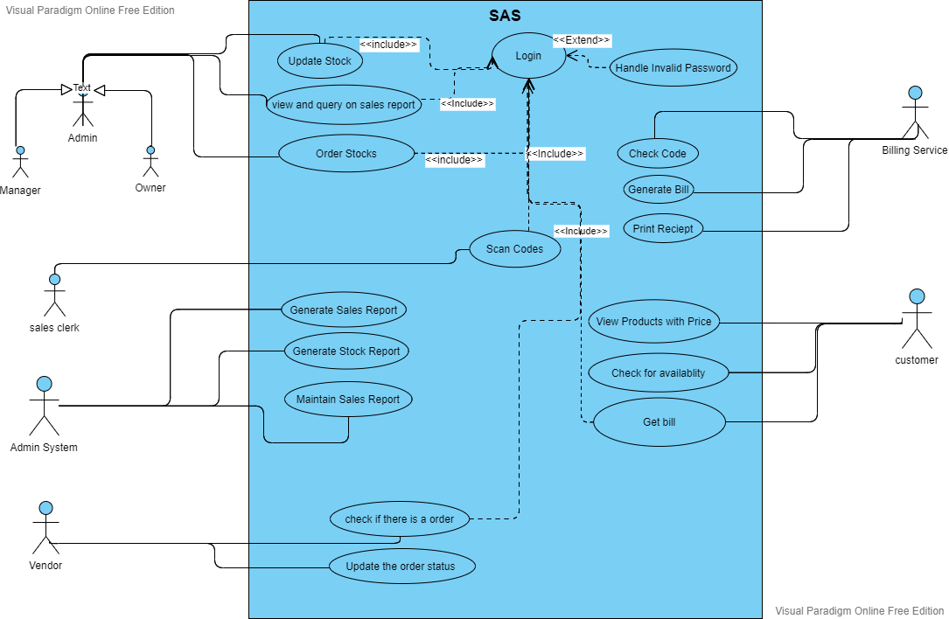

## 2.3 User Classes and Characteristics

The system provides different types of services for different types of users. The system will have four basic user classes:

1. Admin

Admin includes the Owner and the manager They will log in with an admin account and get all admin rights like only they can check the supermarket sales report ,check the need of stocks and place an order to the vendor, also they can check all kinds of transaction like manager to vendor payment for stock refill and costumer to sales clerk payment for the goods that costumer buys.

1. Sales Clerk

All the sales clerk will get a userid and password and they will log in as employee. They will scan codes of the goods bought by the buyer and the system will generate the bill and the transaction history will be stored in his account and he can check that.

1. Vendor

Vendors will also get userid and password. He will get the notification of any order placed, also he can update the delivery status.

1. Buyer

Buyers can login into the system.

Can view the list of the product available

Also they will get the bill in their registered mobile no.

## 2.4 Operating Environment

* OS- Windows7, Windows8, Windows10, Android
* Processor: 1 gigahertz (GHz) or faster processor
* RAM: 1 gigabyte (GB) for 32-bit or 2 GB for 64-bit
* Hard disk space: 16 GB for 32-bit OS or 20 GB for 64-bit OS

## 2.5 Design and Implementation Constraints

The Application will follow the following design constraints:

The UI/UX design of the application should be simple and user friendly.

This project is designed to be extensible, that is open to changes.

## 2.6 User Documentation

* Instructions will be given to the user through Pop Ups/Notification on their first usage of App.
* Also a pdf regarding "How to Use The App" is given in Help Section.

## 2.7 Assumptions and Dependencies

Assumption:

* The Owner is given the rights/access to enter the system and make the required changes (if any).
* The system would be user friendly, so that everyone can use that easily.
* All the data is saved in the data base: Employee information, product information, sales information

Dependencies:

* The browsers should be properly up to date.
* Network connection should be stable.

# 3.External Interface Requirements

**3.1 User Interface:**

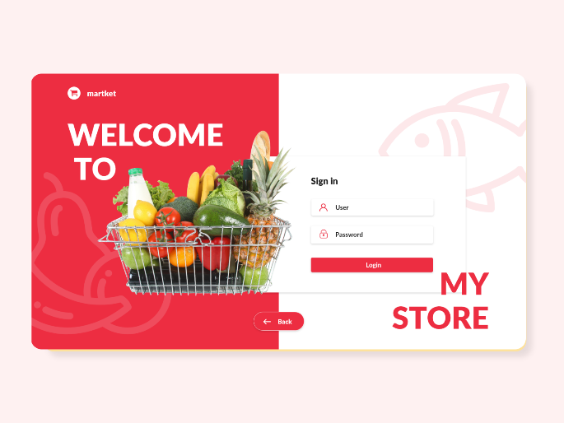

**3.1.1 Manager Interface:**

The SAS screen displays interfaces to view the inventory, change the prices of the products, view and print sales statistics, offer and discounts.

**3.1.2 Salesclerk interface:**

The SAS screen displays an interface to commute a transaction with a customer and produces and prints a bill for the transaction.

**3.1.3 Supermarket staff interface:**

The SAS screen displays an interface to update the inventory for the supermarket with each arrival of new supplies also maximum and minimum quantity of product bought by customer.

**3.1.4 Hardware interfaces**

For the software to function properly, a bar code reader is required which will scan the bar code from a product and sends the product ID to the software and the weighing machine sends the weight of the product and a desktop.

**3.2 Software interfaces**

********

**3.3 Hardware interfaces**

For the software to function properly, a bar code reader is required which will scan the bar code from a product and sends the product ID to the software and the weighing machine sends the weight of the product.

Also a desktop and a printer will be necessary to use the system and generate bill respectively.

**3.4 Communication interface:**

Any changes made to the inventory of the supermarket is automatically updated in the database which has been set up in a separate server in the supermarket itself by owner.

**4.0 System Feature**

**4.1 System Feature – 1**

**Usecase:** Log-In

**Actors:** Buyers, Sales clerk, Manager, Owner

**Scenario:**

1. Buyer and supplier select whether they are new user or regular user.

2. If new user then buyer and supplier both must enter details like name, date-of-birth (D.O.B), address, email-id, password, phone number.

3. System authorizes the user.

**Alternate scenario:**

2a. If regular user, then system ask to enter phone number and email id and password.

2b. On successful logging in, the customer can proceed for payment and the suppliers can take their order.

**4.2 System Feature-3**

**Usecase:** Managing stock

**Actors:** Shop-Owner, Manager

**Scenario:**

1. Shop-Owner and manager will get notification through the system if there is a limited stock of some item

2. If items are required, then Shop-Owner or the manager can the place order to the vendors through the system.

**Alternate Scenario:**

2a. System send a message to Shop-Owner on successful updating of placing order stock.

**4.3 System Feature- 4**

**Usecase:** Sales Report

**Actors:** Shop-Owner, Manager

**Scenario:**

1. Shop-Owner enters the respective date for which sales report needs to be generated.

**Alternate Scenario:**

1a. System checks the date and then generate sales report.

* a.i. System displays error message if fails to check the date.

**4.4 System Feature- 5**

**Usecase:** Billing

**Actors:** Sales clerk, Customer

**Scenario:**

1. First the sales clerk will scan codes of each and every product then the system will generate the bill and will send to the mobile number registered or if new it will register the mobile no. at that time .

2. If regular user, customer has to tell the phone number used during Log In time.

3. The customer selects the payment option from the given options, like- Cash /Credit / Debit Card or Phone Pe / Google Pay or Paytm or Net Banking.

4. System authorizes payment.

5. Customer receives an OTP to confirm and secure his payment.

6. System generates a bill including all details of transaction.

7. System sends confirming message to the registered phone number.

**5.0 Non-Functional Requirement:**

**5.1 Performance:**

High level of performance requires high speed network and high level of connectivity. The system is developed suiting for the least system performances. When consider about the timing relationships of the system the load time for user interface screens shall take no longer than two seconds. It makes fast access to system functions.

## 5.2 Availability:

The Software will be available all the time, the customers will

have the access to the web view all the time also, it will show the

status of the supermarket (open or closed).

**5.4 Reliability**:

## The available server must be reliable and the network connectivity in the supermarket should be proper for smooth flow of all operations and data.

## 5.4 Security:

The admin and sales staff will have a unique userid and password through which they can login to their account in the software. And the customers will have to give the mobile number or email and password to login to their account. Every user of the software is provided a password which is stored in the database hashed and salted by bcrypt’s NodeJS library.

**5.5 Other requirements:**

* The software does not allow the inventory to be reduced from the database without the concerned item being purchased.
* The software does not allow any other person except the managers and owner to change the price of the products.